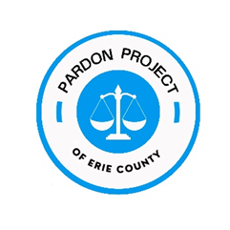
PARDON PROJECT OF ERIE COUNTY
Eligibility Criteria

- A residence in Erie County or a criminal conviction in Erie County (as long as not living in a county with its own Pardon Project)
- No open cases
- Household income at or below 150% of the federal poverty guidelines (https://aspe.hhs.gov/poverty-guidelines).
- At least 3 years have passed since completion of most recent sentence; exception: 8 years must have passed from the date of completion of sentence (to ensure that 10 years have passed before the application is heard by the Board of Pardons) for any crime involving registration of the offender under SORNA or any of the following crimes (in all such cases, admission into program will be on a case-by-case basis):
  - Rape.
  - Drug delivery resulting in death.
  - Any felony involving sexual conduct.
  - Robbery involving violence to a person.
  - Robbery of a motor vehicle.
  - Aggravated assault.
  - Kidnapping.
  - Voluntary manslaughter.
  - Murder.
  - Arson.
  - Attempt, conspiracy or solicitation to commit the above crimes.
- Individuals who were juveniles at the time of the crime and convicted in adult court
- Payment of amount due in restitution and fines (not including court fees and costs) is possible within 2 years – as long as there is a payment plan in place and being followed.
A Pardon Project Volunteer always has the right to decline a referral, for any or no reason.
If, after investigation, a Pardon Project Volunteer determines that a client does NOT qualify for the Pardon Project, the volunteer may decide (in her/his own discretion) whether or not to continue assisting the individual. If the volunteer declines to proceed further, the Pardon Project will notify those individuals who do not qualify that they are being declined from the Project.

As Adopted, July 16, 2021

